**Administrator:**

Description

# Dashboard - Provides a complete overview of contracts which are on different stages. An Admin user can access the dashboard by clicking ‘Dashboard’ option on the left of Contract Management System Application.

# 1.1 Pending Sign-Off – Displays Number of Approved Contracts and the overview of them. Below are the steps to access Pending Sign-Off table.

1. Pending Sign-off count appears at the top side of Dashboard.
2. Clicking on Pending Sign-Off count navigates to the Pending Sign-Off Table.
3. 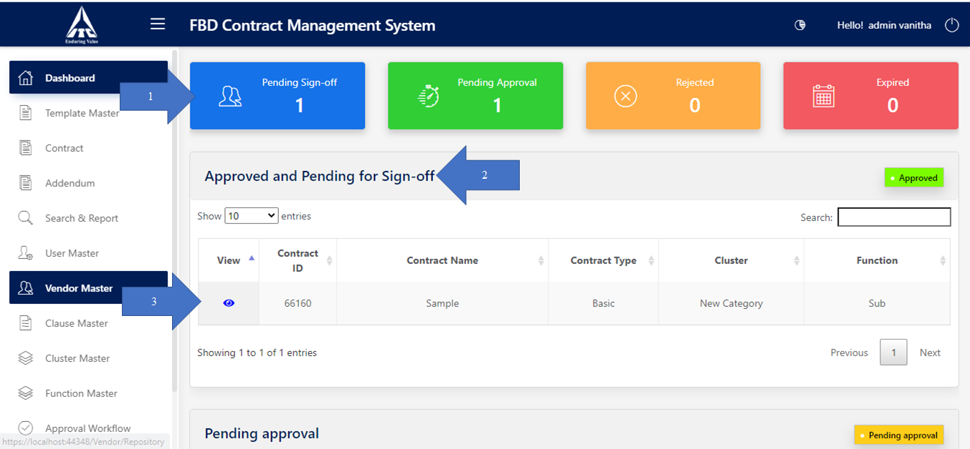Clicking on View icon opens the particular Contract.

# 1.2 Pending Approval – Displays Number of Contracts which are pending for Approval. Below are the steps to access Pending Approval table.

1. Pending Approval count appears at the top side of Dashboard.
2. Clicking on Pending Approval count navigates to the Pending Approval Table.

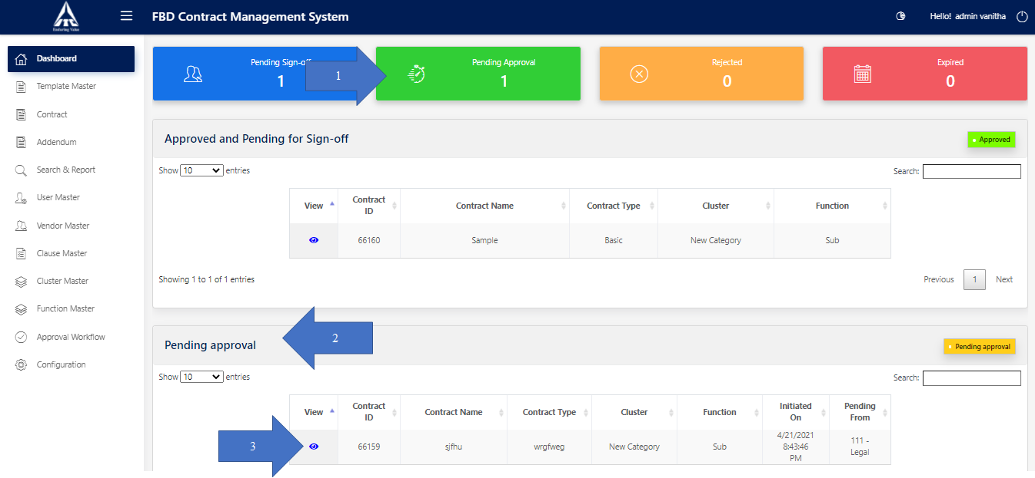Clicking on View icon opens the particular Contract

# 1.3 Rejected – Displays Number of Contracts which are Rejected by the Approvers. Below are the steps to access Rejected table.

1. Rejected count appears at the top side of Dashboard.
2. Clicking on Rejection count navigates to the Rejected Table.

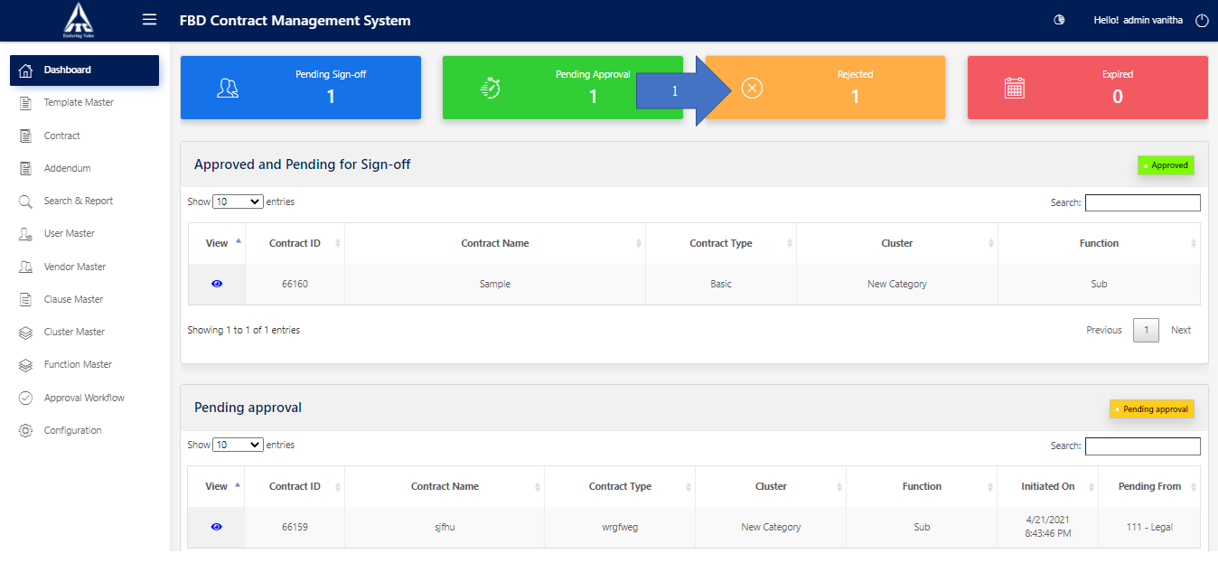Clicking on View icon opens the Rejected contract

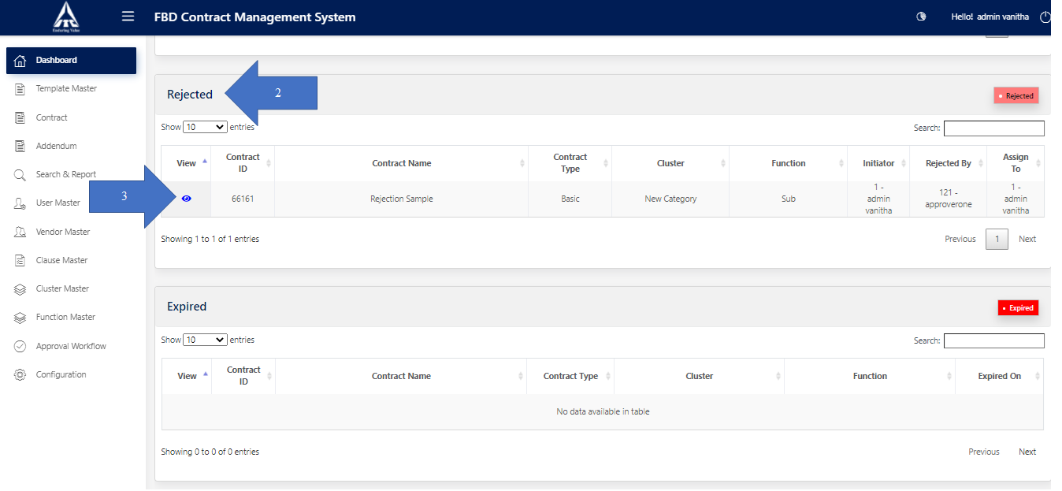

# 1.4 Expired – Displays Number of Contracts which were Expired. Below are the steps to access Expired table.

1. Expired count appears at the top side of Dashboard.
2. Clicking on Expired count navigates to the Expired Table.
3. 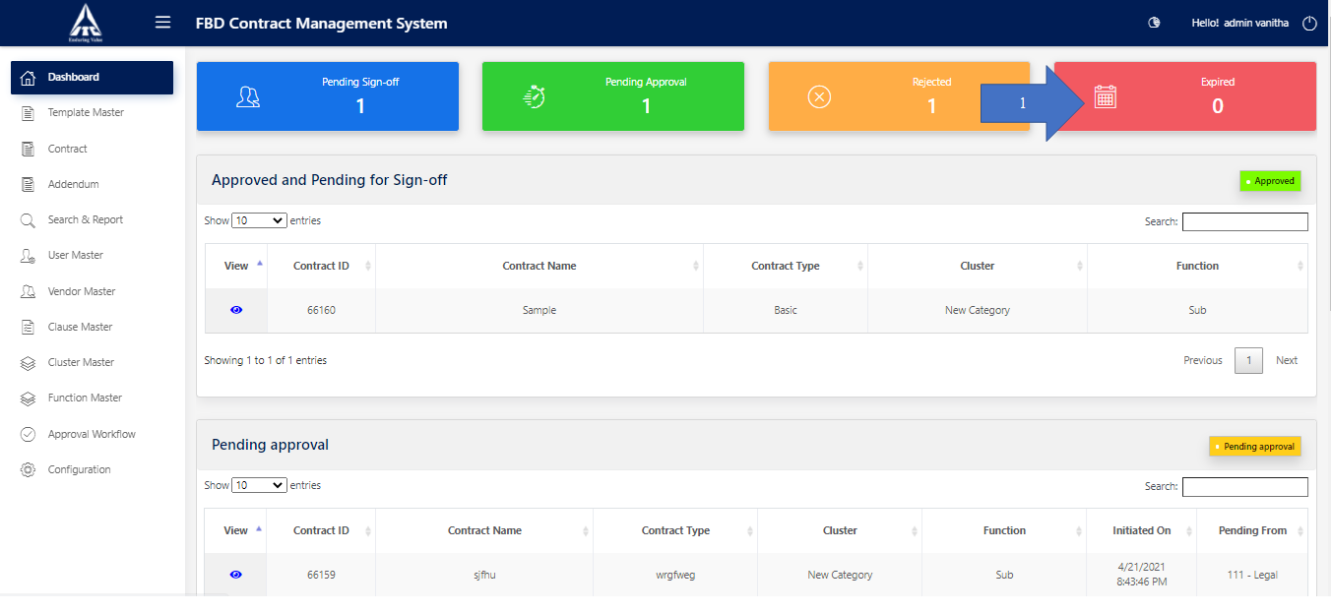Clicking on View icon opens the particular Expired contract

